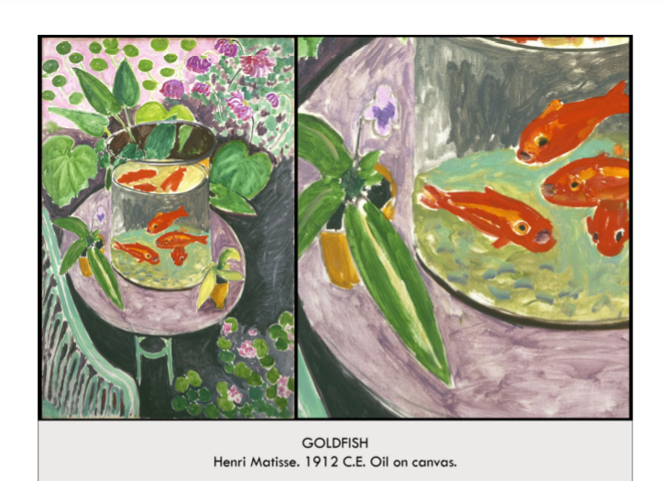

| **Form:** brush strokes from post-impressionism, avant-gard modern art, shows the color of fauvism. 1912 belongs to a series that Matisse produced between spring and early summer 1912. However, unlike the others, the focus here centers on the fish themselves.  **Function:** a still life painting. Decoration. use vibrant colors to evoke an emotional response. contemplative relaxation for the viewer  **Content:**  a still life painting, shows a flatness, sense of space is flat, it is made flat deplipretly, very painterly, 2D abstract quality of islamic pattern making. Shows a reflection on the water. still life painting, violent contrasts of color, thinly applied colors—white of the canvas shows through, energetic brushwork influenced by asian art? (so decorative) bright orange strongly contrasts with the more subtle pinks and greens that surround the fish bowl and the blue-green background= used contrast. And complimentary color. Goldfish represent tranquility  **Context:** He was inspired by ilsamic art, and throughout the painting be is attempting to use patterns. It is a Fauvist painting ( qualities: Color, Abstraction, Brush strokes) the beginning of modernism**, Fauvism**— art movement that debuted in 1905 in Paris(named from a critic who thought the paintings looked like they'd been painted by "Wild Beasts") inspired by post impressionists (Van Gogh, and Gauguin) stressed a painterly surface with broad flat areas of violently contrasting color. maximize expressive effects by suppressing figure models and color harmonies **Matisse**- french, one of the biggest figures in the development of modern art (along with Picasso), loved to explore the expressive potential of color and its relation to form. colors are emotions, not reality. famous for decorative style, expressive forms, bold use of color, make art, don't imitate nature. Goldfish= went to Morocco, and everyone would stare at goldfish contemplatively all day long, relaxed lifestyle, goldfish became a symbol for paradise lost, a tranquil state of mind. "an art that could be....a soothing, calming influence on the mind, something like a good armchair that provides relaxation from fatigue.” - Matisse. Goldfish appear in no less than nine of his paintings. Could have been inspired by his trip to morocco. Liked their relaxed and contemplative style. art of Islamic cultures, was interested in the meaning of gardens, water and vegetation in [Islamic art](https://smarthistory.org/arts-of-the-islamic-world/)—as well as symbolizing the beauty of divine creation, these were evocations of paradise.  **Compare:** dutch still life, falt islamic patterns.  **131**  Late Europe & Americas |
| --- |

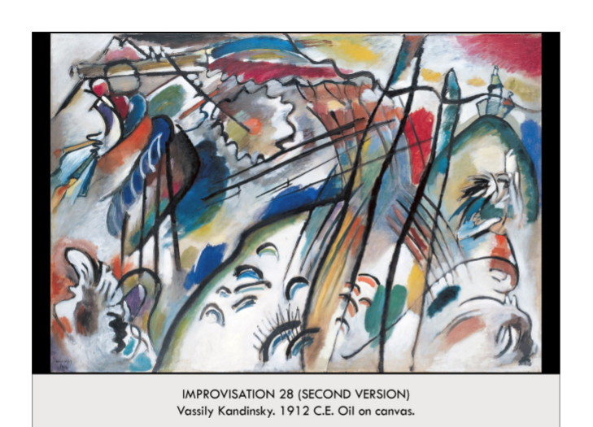

| **Form:** german expressionism. Non-objective art( no referent to the natural world) art. Oil painting on canvas. About body sized painting.  **Function**: first example of Non-objective art( no referent to the natural world) art . invention, spiritual search, design, color and expression. to have the viewer respond to a painting the way one would respond to an abstract musical composition like a concerto, sonata, or symphony, title derived from musical compositions;gave musical titles to his works like "composition" and "improvisation"  **Content**: The painting in flat, and in one plane. Was intended for you to think of classical music when looking at this. ( abstract version of music) wanted to show that experience of paint=radical. movement towards abstraction, representational objects suggested rather than depicted, strong black lines, colors shade around line forms  **Context:** he was searching for the spiritual in art using paint and abstraction=modern. The art was inspired by music. Expressionism— inspired by the Fauve movement. Die Brüke (The Bridge) movement, they saw themselves as "the bridge" from traditional to modern painting, violent juxtapositions of color. **Der Blaue Reiter** (The Blue Rider) movement( german group, named because the founders liked horses and the color blue) abstraction, a way to conceive the natural world in terms that went beyond representation, if there are recognizable forms then our conscious minds will take over, and we would close off our emotional ability to respond to color and form…Kandinsky, big part of Der Blaue Reiter, wrote essay called *Concerning the Spiritual in Art* which outlines his theories on color and form for the modern movement. felt that sounds and color were linked (synesthesia). art should express an inner spiritual necessity. Russian. one of the first artists to make non-objective, or completely abstract, paintings  **Compare:** Flat modern paintings form the time. Jackson pollock.  **132**  Late Europe & Americas |
| --- |

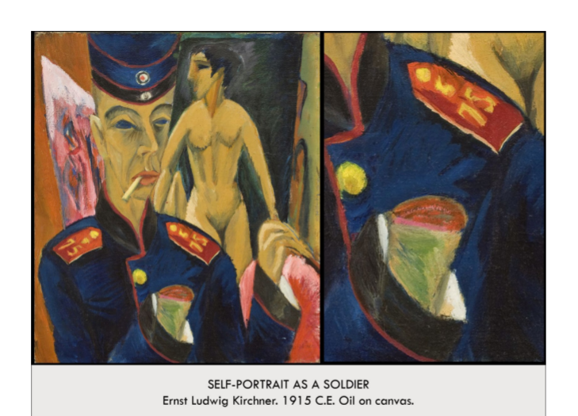

| **Form:** oil painting  **Function:** expressing himself, to show that being ing the army is cutting off his painting hand. Kirchner never fought, and this painting is instead an exploration of the artist’s personal fears. The severed hand in *Self-Portrait As a Soldier* is not a literal injury, but a metaphor  **Content:** there is a self portrait with his hand cut off, in the back is a nude women wich expresses what he use to be able to paint. The perspectives are tilted and it is a modern expressional painting which is a painting that grows out of Vincent and Munch. It is a subjective, abstract painting. a masterpiece of psychological drama. The painting shows Kirchner dressed in a uniform but instead of standing on a battlefield (or another military context), he is standing in his studio with an amputated, bloody arm and a nude model behind him. It is in this contrast between the artist’s clothing and studio space that we can read a complicated coming of age for an idealistic young artist.  **Context:** Made after he was conscripted into the german army, and he was unwilling and did not wan be be there. Modern art.During the war, Kirchner suffered from alcoholism and drug abuse and for a time his hands and feet were partially paralyzed.. In 1905, Kirchner, together other young artists from Dresden founded the German Expressionist group *Die Brücke* (The Bridge) Kirchner was a great admirer of the German philosopher Friedrich Nietzsche. Nietzsche’s book, *Thus Spoke Zarathustra* uses the bridge as a metaphor for the connection between the barbarism of the past and the modernity of the future. The *Brücke* artists considered themselves the inheritors of this idea, and created art that looked to the past and the future at once. They found inspiration from “primitive” art (art and ritual objects from ancient cultures or nonwestern societies, particularly in Africa and Central Asia). Showed honesty and was direct, also inspired bu “folk art” *Brücke* artists were inspired to adopt the “natural” state that they perceived in “primitivism” in their lives and their art.  **Compare: *Self-Portrait with Model* (1907/26)**  **133**  Late Europe & Americas |
| --- |

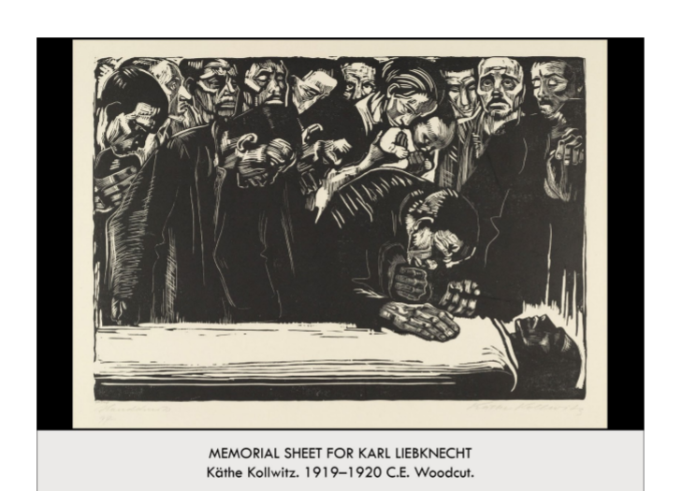

| **Form:** (woodcut, oldest form of the german art) in the style of a [lamentation](https://smarthistory.org/christ-virgin-byzantine-art/#:~:text=NC%2DSA%202.0)-,The%20Lamentation,-The%20Lamentation%2C%20or), a traditional motif in Christian art depicting the followers of Christ mourning over his dead body, casting Liebknecht as the Christ figure. The iconography would have been easily recognizable by the masses who were the artist’s intended audience. Woodblock printing is a technique in which a design is carved into a slab of wood which is then covered with ink and printed onto paper. Ink coats the original surface of the wood block, which prints as black, while the cut away areas stay the color of the paper.  **Function:** a image to celebrate and morn this communest leader who was killed. created in 1920 in response to the assassination of Communist leader Karl Liebknecht during an uprising of 1919. This work is unique among her prints, and though it memorializes the man, it does so without advocating for his ideology.  **Content:** it is balck and white, and very linear, carl was founder of german communeats party and in 1919 he was shot to death during communest uprising called spartacus revolt, entire image is about grieving this communest leader, artiest has political sympathy for his, it shows people that corpes is in a unique composition at the bottom of the image, with the other people towering above. Lines are used to express light. The composition divides the sheet into three horizontal sections. The top section is densely packed with figures. Faces, modeled and have depth in themselves,sense of space is very compressed – the heads push to the foreground and are packed into every available corner of space. It gives the impression of multitudes coming to pay their respects, without compromising the individuality of the subjects.  The middle contains comparatively fewer details, further emphasizing the crowding at the top of the printing plate. This section draws attention to the specific action of the bending mourner. His hand on Liebknecht’s chest connects this section to the the bottommost level of the composition, the body of the martyred revolutionary.  **Context:** The artist was directly related to and witness much war, pain and suffering. Many artist turned to prints after the war, so they could reproduce and sell mare of their work. And it also made is easy to spread political statements of information. Käthe Kollwitz worked almost exclusively in this medium and became known for her prints that celebrated the plight of the working-class.  **Compare:** the prints of albet Durr and the woodcut tradition, Lamentation painting from giotto( jesus down), Max Beckmann’s “The Martyrdom” from his portfolio *Hell* of 1919  **134**  Late Europe & Americas |
| --- |

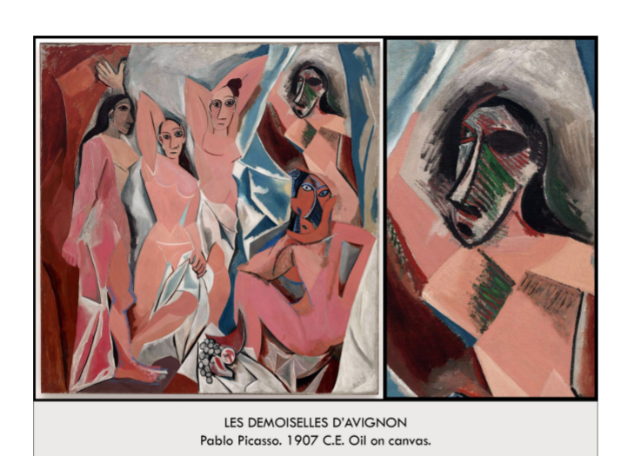

| **Form:** large painting, Oil on canvas. The painting is flat and there is no perspective, 2D conglomeration of shape, there is no curiscuro. The colors are strong and clashing,  **Function:** subjective representation of abstraction. It is about his fear of women, that these women are provoking him. A painting with no narrative. Picassos investigation and experience in what painting is, and who women are/ what women is.  **Content:** an image of his girlfriend of the time over and over again in different representations, the faces come from african masks which he was influenced from. ( tribal masks). Eye contact, scarification of bodies, heads turned around. The “background” shows broken shards of glass. The the women( girlfriend or prostitute) is shown as ugly and angular. radically compressed the space of his canvas and replaced sensual eroticism with a kind of aggressively crude pornography. (Note, for example, the squatting figure at the lower right.) His space is interior, closed, and almost claustrophobic. the women fill the entire space and seem trapped within it. No longer set in a classical past, Picasso’s image is clearly of our time. two figures at the right are the most aggressively abstracted with faces rendered as if they wear African masks Each of these male figures was meant to symbolize an aspect of Picasso. Or, more exactly, how Picasso viewed these women.  **Context:** Picasso was a spanish painter and he paints in different periods, he said “it took 4 years to paint like raphael and a liftimes to paint like a child.” Blue period(sad depressing drewery -rose period( brighter pallet more joy and heroic) made over june and july, when picasso was on opioid and he was basically a mess. Purchased in 1930. He could not display this because “it was to dangerous” Changed how people viewed art( art was going to be inventive, and proactive) shows a complete abstraction of the human form, and diverges from anything seen before. It altered the goal of art( to make things ugly) he also gets rid of narrative and is not saying anything. Inspirations from the old caves( prehistoric) an unforgettable piece. ( only thing he is not doing is getting rid of subject matter, still refers to the nude, this compares to what menet does, ( takes the nude and makes it horrific) constructed in response to [Cézanne’s](https://smarthistory.org/an-introduction-to-the-painting-of-paul-cezanne/) great achievement at the posthumous retrospective mounted in Paris a year after the artist’s death in 1907. And especially Matisse’s [*Bonheur de Vivre*](https://smarthistory.org/matisse-bonheur-de-vivre/) of 1906  **Compare: g**iotto's lamentation( 20th century equivalent) African influence( african masks)  **126**  Late Europe & Americas |
| --- |

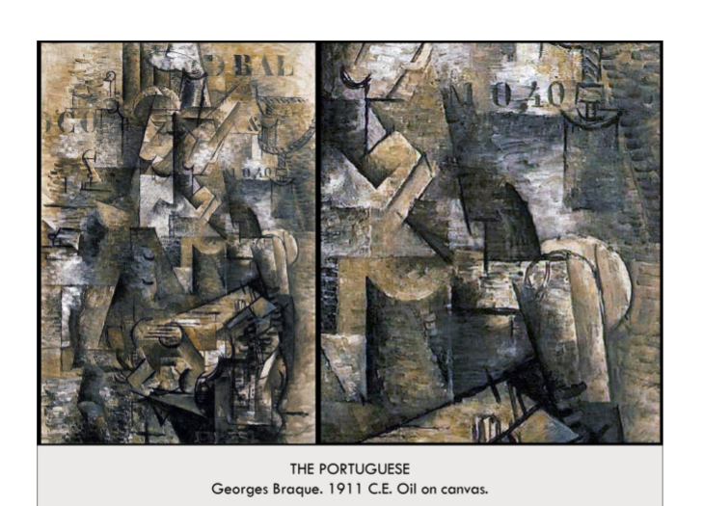

| **Form:** example of Cubism/ synthetic cubism  **Function:** invention and exploration of a new type of painting/art. A painting you have to interpret and it creates an experience. To shows all sides of a subject. want to express my total visual understanding of the object.  **Content:**  a man who is looking down and playing a guitar/ instrument, ina cafe, the entire image is distorted and scene from many different views, the mans hand is seen multiple times as it is moving throughout the painting. Paintings of a still like using Cubism techniques. neither naturalistic nor conventional, fractured forms, clear edged surfaces on the picture plane—not recessed in space. nearly monochrome, not a portrait of a portuguese musician, but rather an exploration of shapes. only realistic elements are stenciled letters and numbers. The guitar player and the dock was just so many pieces of broken form, almost broken glass. By breaking these objects into smaller elements, Braque and Picasso are able to overcome the unified singularity of an object and instead transform it into an object of vision  **Context:** cubism was created/ developed by Picasso and Braque, These painting are intended to be a reason from art. Analytical Cubism (1907-1912)= first phase of cubism, highly experimental, jagged edges, sharp and multifaceted lines. Worked with Picasso to develop this style "By breaking these objects into smaller elements, Braque and Picasso are able to overcome the unified singularity of an object and instead transform it into an object of vision" …”express the entire cup simultaneously on the static surface of the canvas since I can hold all that visual information in my memory. I want to render the cup’s front, its sides, its back, and its inner walls, its bottom from both inside and out, and I want to do this on a flat canvas.”  **Compare:** Dutch still life( one is like a camera and one is to just envent and enjoy)  **130**  Late Europe & Americas |
| --- |

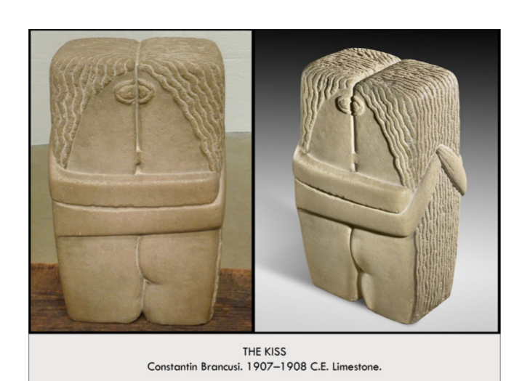

| **Form:** a limestone sculpture. The forth version of this sculpture, meant to be directly placed on the ground.  **Function**: as a commission for a america collector. , to show a new for of abstraction in sculpture. Was a bridge from 19th century to 20th century sculpture. An attempt to obtain the materialist, the figures are part of and move with the stone.  **Content**: cubist. Symbolist work. An almost primitive figure of sculpture, their arms are around each other, two people are becoming one. Their eyes are combing. They are embracing agents each other , and their bodies are pressed together. Fragmented the human figure. The figure plates and destroys the idea of a ideal sculpture. Very simple and block like, forms are not detailed. Are separated by a single line. The “women is a little slimmer and smaller. And there eyes and lips are combining.  **Context**: a french sculpture, who worked with rodan, and worked. The fourth version and done as a commission. 1st was work, 2nt was in show. 3rd was tomb ston— there are many versions. It was in a way the birth of abstract sculpture, and he was doing something new, and transferring the new ideas in art, in sculpture. He was a romanian artist, but made his way to paris. Speaks of something primitive, and natural, archaic, and going back to before the classical. A very radical piece because it did not show a technical property. Looks for truth in nature, and shows the avant-garde becing it is more reflective of the time the artist lives in and rejects the art of idealis and the otherwise refined sculpture.  **Compare**: clinmts the kiss.  **129**  Late Europe & Americas |
| --- |

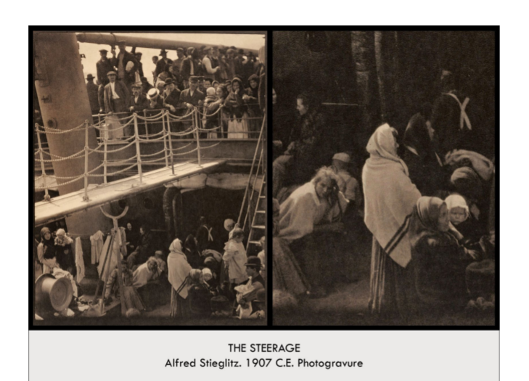

| **Form:** Photography, made with his hand camera. Shows an early image of popular straight photography — an image that shows truth beautifully.  **Function:** A photograph to show class, and a demonstration of straight photography. suggests that photographs have more than just a “documentary” voice that speaks to the truth-to-appearance of subjects in a field of space within narrowly defined slice of time. Shows a more complex and layered view of photography’s essence that can accommodate and convey abstraction.  **Content:** In focus, not tricks and unposed, he is on a sip and on his way to europea, an image of class, the first class are at the top level and the poor are on the bottom, and wanted to show a union between the two levels. The composition made it into an artistic experience.  **Context:** He was the father of American photography, first person to show photos as an art form, he is usually a pictoraist. An example of where photography is going in the 1920’s. Shows that photography is an art form- how arrangement leads to emotion =, statement, and everything other art like painting can do. Taken on the ship Kaiser Wilhelm II. He was said to have been going through a lot of stree and felt out of place among the upper class passengers on the ship. conveys a message about its subjects, immigrants who were rejected at Ellis Island, or who were returning to their old country to see relatives and perhaps to encourage others to return to the United States with them.  **Compare:**  **127**  Late Europe & Americas |
| --- |

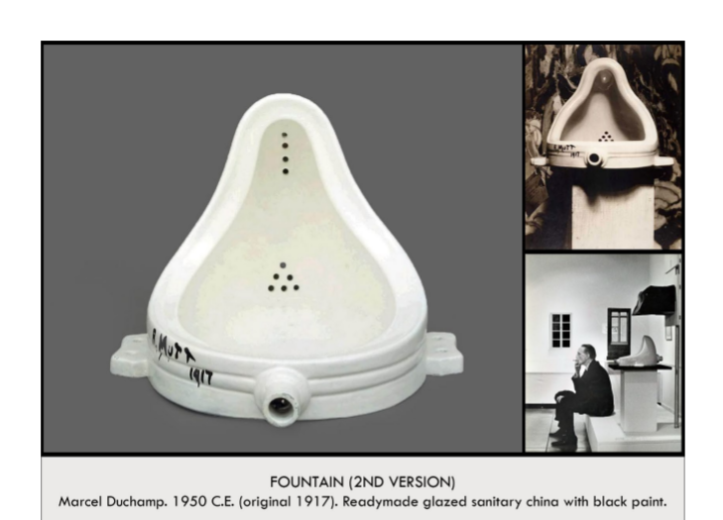

| **Form:** porcinline, industrially made mens urinal. Readymade sculpture, signed R. Mutt as a pun  **Function:** an ironic sculpture, challenges definition of art and puts “sculpture” in quotes. Ironic for being upside down and as a plan on a cartoon strip of time, Mutt and Jeff.  **Content:** mens urinal turned on its side and singed it with a funny name/ ironic.  **Context:** created using DADA( which worked with irony, Absurdity, poacative) he was a very ironic person, he would dress in drag and take picture, he was someone who challenged what art was. Challenged the meaning- do artist have to make something to be artist? “The world is already full, we don't have to make them anymore. Showed a bottle rack, signed snow shovel, and signed a men's urinal. Dada embraced absolute invention. Made during the Dada period of art, Dada was a random word with not clear origin- nonsense. It was a reaction to horrors of WWI. DAdaist rejected conventional methods and manners. They worked with new unique mediums. They preferred concept over execution  **Compare:**  **144**  Late Europe & Americas |
| --- |

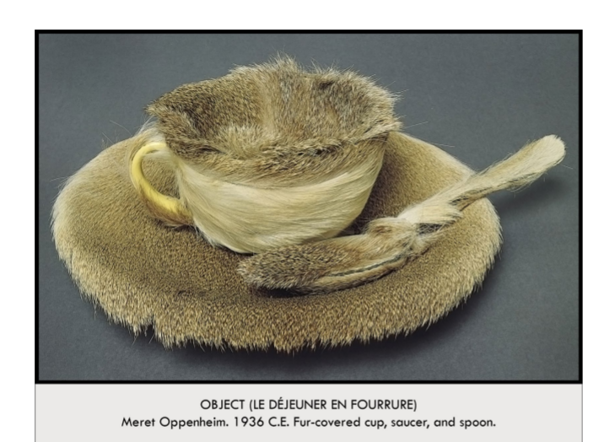

| **Form:** a purchased cut assembled with fur around it.  **Function:** A very large part of the surrealism movement.  **Content: it is a tea set which is covered in fur.**  **Context:**  Both made a ruined her career, it was very famous and represented surrealism movement. Was the last work she created. Said to be done with picassos clai, everything looks better with fur.  **Compare:** Duchamp's fountain, make out of something you can by buy  **138**  Late Europe & Americas |
| --- |

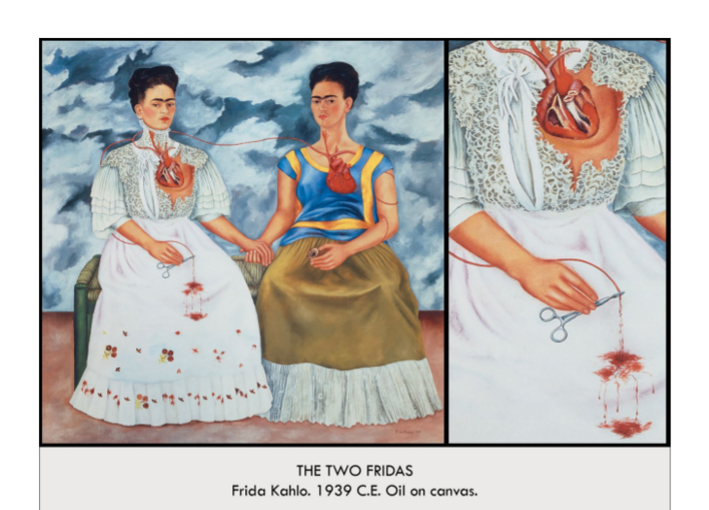

| **Form**: oil on canvas. Shows surrealism  **Function**: showing you she is not one person, but surealistically is two people. About cognitive dissonance, about her identity whether she was spanish or european.  **Content**: Oen left spanish painting wearing white lace, and shows herself asa european aristocrats, and on right she is a mexican peasant. Two hearts and twined together by eines and she has two heart. When then are entwined they are cut at the end and bleeding. She is holding a picture of her husband, diego. The blood represends abortions and misscarages she had had. The background sky is active and full of clouds, but the landscape is barren.  **Context**: who of the only artist whos only purpose in art was to express herself. Wa painted at the time of their divorse  **Compare:**  **140**  Late Europe & Americas |
| --- |

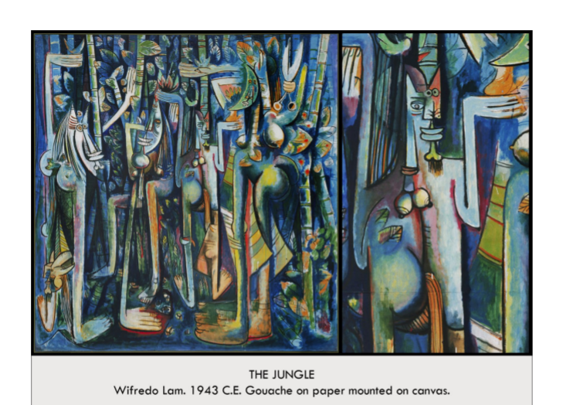

| **Form:** oil on canvas.  **Function:** part of the surrealism movement, a response to picasso.  **Content:** composition depict a jungle in cuba and ( a combination of cubism and surrealism and the canvases of the upcoming new york school) 4 hybrid figures with long legs, buttox. 2 figures have a horse tail, and a figure with scissors - as if it was the one to cut herself and the other figures abarth. The setting was thought to be surrounded by either sugar cane or some other plant.  **Context:** A surrealism painting. He was a cuban painter, he fought in the spanish civil war, he was influenced by picasso, who he met. Many think it is his response to picasso’s painting.  **Compare:** picasso, le diss…. - figurative paintings of the figure  **142**  Late Europe & Americas |
| --- |

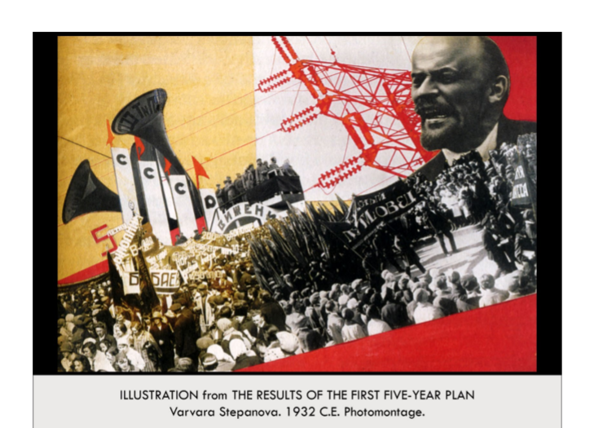

| **Form:** a collage of news paper and magazine paper, a photomontage- process of making a composite image by juxtaposing or mounting two or more photographs in order to give the illusion of a single image. A photomontage can include photographs, text, words, and even newspaper clippings.( because it can be reproduced) images glued onto a piece of paper  **Function:** illustration for a public pamphlet distributed to the people to show the 5 year plan to make a new form a government= communism. Piece of political propaganda= to support a new government.to show countries such as France and Great Britain that the USSR was also a leading force in the global market and economy. By choosing to include images rather than just articles, the public would be able to see with their own eyes the accomplishments achieved under Stalin..ode to the success of the First Five-Year Plan, an initiative started by Stalin in 1928. The Plan was a list of strategic goals designed to grow the Soviet economy and accelerate its industrialization.  **Content:** an image of the people in locks, strong colors, diagonal lines and gustial position. Red is color of the soviet union, uses only three types of color and tone. She alternates black and white with sepia photographs and integrates geometric planes of red to structure the composition. On the left, Stepanova has inserted public address speakers on a platform with the number 5, symbolizing the Five Year Plan along with placards displaying the letters CCCP, the Russian initials for USSR. The letters are placed above the horizon as is a portrait of Lenin, the founder of the Soviet Union. The cropped and oversized photograph of Lenin shows him speaking; his eyes turned to the left as if looking to the future. Lenin is linked to the speakers and letter placards at the left by the wires of an electrical transmission tower. Below, a large crowd of people indicate the mass popularity of Stalin’s political program and their desire to celebrate it.  **Context:** russian artist promote the utopian ideal in two movements: Suprematism and constructivism. It was a new movement of art is Russia. between 1905 and 1922 the country underwent tremendous change, the result of two wars (World War I, 1914–18 and Civil War, 1917–22) and a series of uprisings that culminated in the October Revolution of 1917. The Union of Socialist Soviet Republics (USSR) was established in 1922 under Vladimir Ilyich Lenin Russian avant-garde had experimented with new forms of art for decades and in the years after the Revolution, photomontage became a favorite technique  **Compare:** owth of the horatii. Mt satom on the way to an yang  **137**  Late Europe & Americas |
| --- |

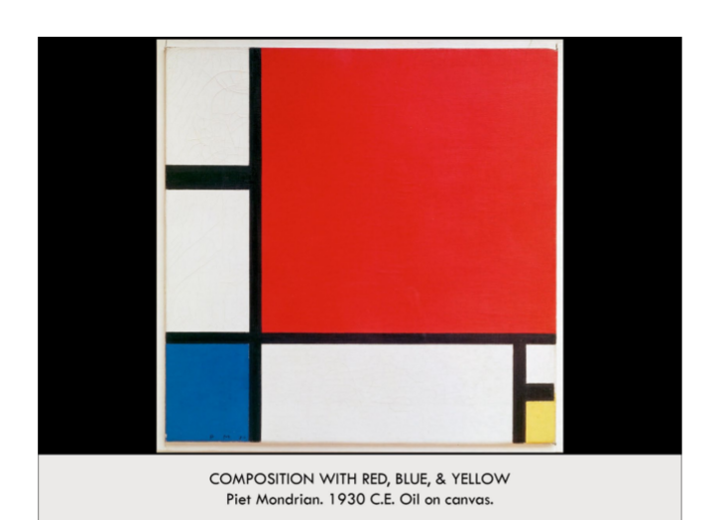

| **Form:** Oil on canvas, small painting. Square painting. He spend moths on it and experimented much, not simple.  **Function:** to demonstrate a new form of art/ style called De Stijl. A utopian ideal. His basic ingredients of everything  **Content:** tiny square of yellow balanced by red, rectangles of solid primary colors outlines with thick black lines separating them. Much of inspiration was from the smooth lines of the machine and technological age. Portrait of a pure, timeless, perfect reality, has distilled everything to the most plastic forms( horizontal lines, vertical line, black, white and the three primary color. Because with these things you can create anything.  **Context:** Post war modern are, style of De Stijl. He wanted to find a simple form of art. It waa a time of suffrage after the war, and artists had to become unique and creare interesting pieces. Piet was a dutch modern aftrs who worked in Paris after the world war.-- The symbol of modernism, he was thinking in an entirely different way, it is artist that invent the world we live in. He was trying to create an utopian form or art. Created in 1930. One of the triumphs of 20th century art.  **Compare**: the zero of all forms by malevich. Phillipe jhonsons sigret building - basic blocks and vertical lines.  **136**  Late Europe & Americas |
| --- |

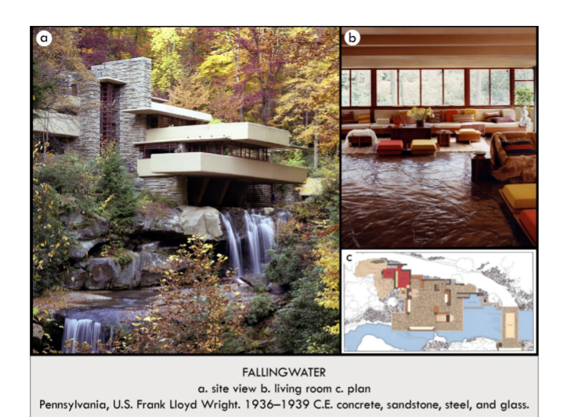

| **Form:**  organic architecture. Created of concrete, sandstone, steel, and glass. Used materials form the surrounding area. Located in the pennsylvania woods.  **Function:** as a vacation home/ weekend home. for a department store manager/ coffman who commissioned the work? To combine nature and architecture.  **Content:** the inside of the house blends with the outside of the house. The interior elevations are perfect and mirror the landscape.. Everyone of the stones in the home are directly from the sight. Build directly over a waterfall. Living room with ribbon windows. Had a terris which extended over the waterfall. The terraces are very prominent and balanced beautifully over the water and the landscape. Featured a flat roof and vertical window( some inspiration from modern architecture). Trusses where made using steel cantilevers to hold them up.  **Context:** all architecture should grow out of its sight ( makes the architecture reflect the surroundings) he designs everything, and every small detail of the buildings he designs. His most famous building, and is the icon of modern architecture. Frank Lloyd Wright worked with teh architect. Also called the coffmen house. “ I want you to live with the waterfall” was designed in two hours. And was built in 2 years. At this time european modernist were taking over, but wright did not like this and wanted to build something within nature.  **Compare:**  **139**  Late Europe & Americas |
| --- |

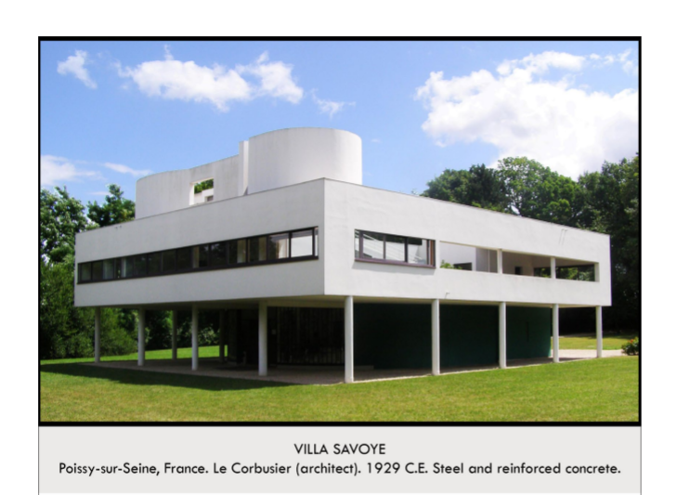

| **Form:**  **Function:** an attempt to create a form or architecture to showing something universal in architecture  **Content:**  wanted to maximize the windows and combine the outside and inside of the building. 3 bedroom villa, designed for a families vacations home. Box like horizontal quality- international. Bottom os a car port, they park underneath and. The roof os a patio, all space in utilized, there is no surface decoration. There is only white on the bullying. Open interior, ribbon window around entire second floor, the furniture is build into the walls and is all attached. Based on the square  **Context:** modernist building. He was a french artist with a single name. He was an architect of the modern age. He winks at classical pillars, but they are just hoding the house up. Modernism and the international style. Piar and emily are the aprtrions of this house. Called a machine of living and inspired by the age of machines and the new technology of the time. International-meant to be global and not represent any particular culture.  **Compare:** mondrian paintings, - looking for the universal in painting/ universal in architecture.  **135**  Late Europe & Americas |
| --- |

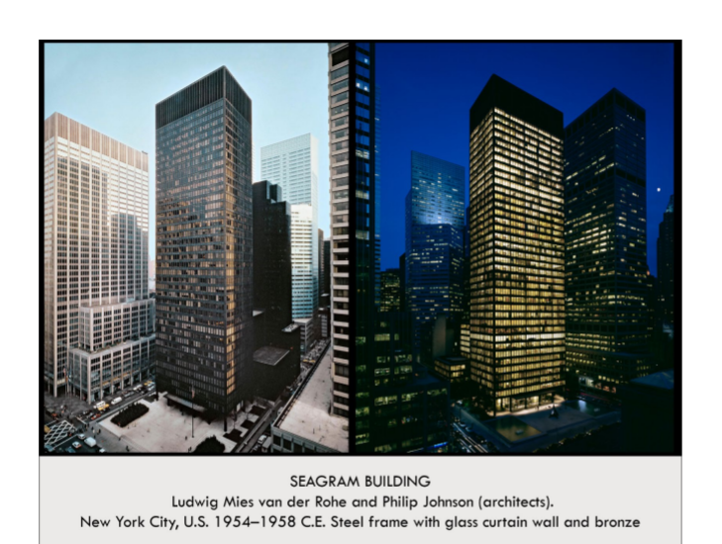

| **Form:** covered in bronze. With a steel frame and glass curtain wall.  **Function:** an international style building.  **Content:** all about the interplay orf horizontal and vertical. It is a series of repetitive verticals with 4 stories of vertical. To top has a beautiful coronis. Vertical, repetition copper beauty= a uniqueness. The top and the bottom, the building ends beautiful added 5 stories of just vertical lines. Begins of stilts of long horizontals so it appears to be lifting off the ground.  **Context:** the international style of architecture. Primary example of the international style. Created during the time of.  **Compare:**  **146**  Late Europe & Americas |
| --- |

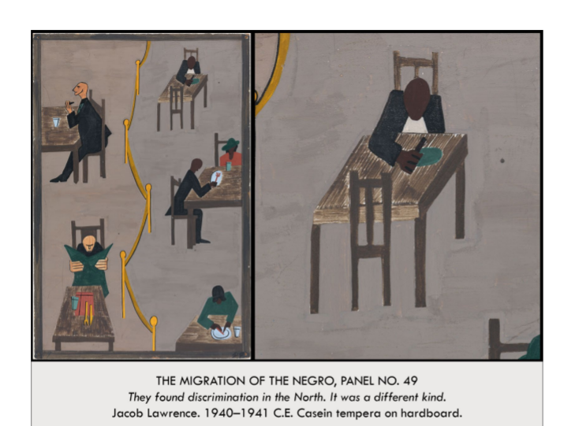

| **Form:**  the paintings are figurative abstraction. Part of the migration series. “ they found discrimination in the North. It was a different kind”- caption of painting.  **Function:**  political, and historical art, which tells the story of African American people in the US. An impactful work that sends a message and tells a story  **Content:** Tells a story through painting, form how they went from being oppressed in the south, then the great migration and travel, and how people suffered rom extreme racism and oppression. Abstract art about journey of African American from the south to the north.  ….THIS painting showed the segregation Black people faced in the north as well, through laws and rules, Using a fence in yellow to show the separation of black and white peoples.  **Context:**  Created during the post war period.  post WW1 migration from the south to the north, they went to cities like chicago and New York, St. Lewis. Part of a series which tells a story of African americans. There were 60 paintings in this series. Shows the beauty in storytelling and recording. Doing it in a modernist language.  **Compare:**  **141**  Late Europe & Americas |
| --- |

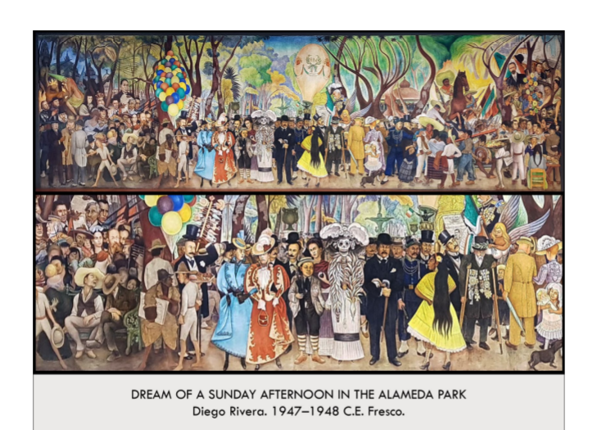

| **Form:**  did in the fresco style. A mural. 50 ft long 13ft high. Is was created on a wall, for the public.  **Function:**  created for the public. Taking about history of mexico, fight for independence, and the rights for the people.  **Content:**  horror vacuole, with hundreds of people. Psychological mix of history, present, future and mythological figures of mexico moves form left to right as time passes. Didactic message is one from the left, he was communiest, believes in worker and poor and wanted self governance. lef t is the path, conquest and colonization of mexico by the spanish, changing the culture, adn putting natives in chain, he is taking the side of the oppressive. And the middle he shows himself as a 10 year old, behind in frida collo. Shows the revolution and fight for mexican independence. On the right is a revolutionary speaker talking to and organizing them, for the workers.  **Context:**  .he use to be a studio painter/ easel painter but had a revelation that are should not be made for the rich, and should be created for the people, and that is what he dedicated the rest of his life and artistic career to. Was originally int he hotel de prado lobby. Done over 2 year period,  **Compare:**  **143**  Late Europe & Americas |
| --- |

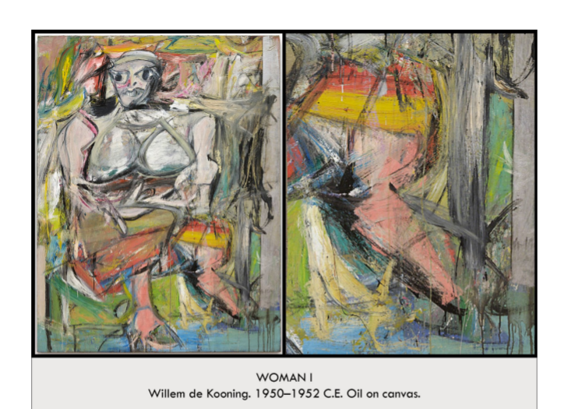

| **Form:**  automatic, gestern, fast. Abstract Expressionism ( automatism, Existentialism, Non-objective action painting) includes all the aspects except for the pact the he is depicting something.  **Function:**  his response to the history of the female nude in painting. As a for of expression.  **Content:**  depicting something to the past . o violent version of the nude. Direct eye contact, and a grimace, and the smile came from a toothpaste model. It is grotesque, as goat hove feet, arms and breasts are emphasized. It is harsh.  **Context:**  dutch artist who moved to america. Part of a series of female nude paintings.  **Compare:**  venus of willendorf, titans olympia= ( the idea of the nide/distorted and a new way to look at it)  **145**  Late Europe & Americas |
| --- |

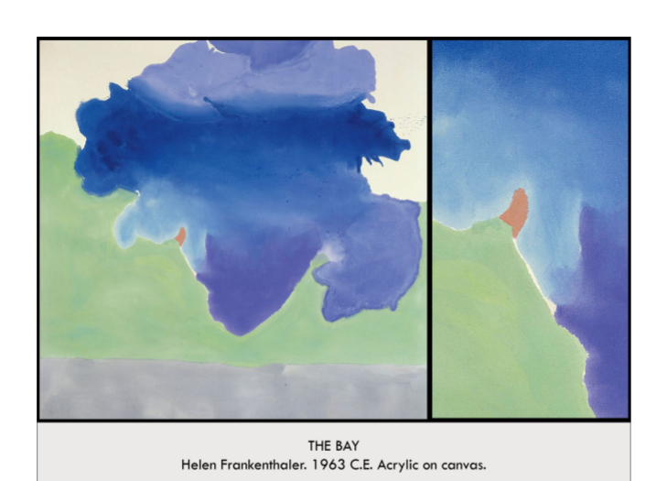

| **Form:** a color field painting. Created by staining the canvas. - thinning the paint and pouring it. They would tip it to let it run down.  **Function:**  **Content:**  incredibly flat to the surface, it is abstract expressionism, ( non objective). In a way the actual making of the art is part of it. Made of stanned colors, unpainted canvas in the top.  **Context:** called color field painting which is a variant of abstract expressionism.  **Compare:**  Joxson pollock- he splattered and she pours.  **149**  Late Europe & Americas |
| --- |

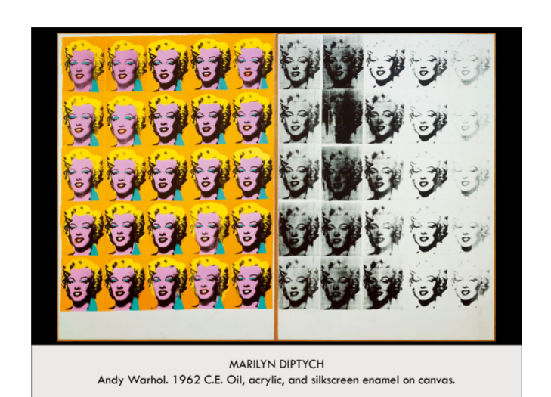

| **Form:**  made from taking a photolithographic photograph . diptych is 2 paintings next to each other.  **Function:**  thought to show the different sides of her, a memorial to marilyn monroe, the left showing her to the public, and the right showing how she actually was and her deeper feelings, ( she dies by suiside)  **Content:** on each there are 25 images of maroline monroe who was a famous actress aadn this photo is taken from a publicity shoot.contains repetitions, and uses color and shadow to depict her face in different and gouty ways. Differently the right is make in black and white, they are faded and dark, they are very ghostly and scratched, smeared, blotchy, dark, ambiguous,  **Context:**  a piece of POP art, which is suppose to be fun, silly and depict insignificant subjects, makes art which is not art in a way. Repetition makes people look, shows the american culture of repetitions and how everything is seen over and over. This was made after she dies.  **Compare:**  Duchamp: urinal and snow shovel- intrutiona and expansitions to the definition of art  **147**  Late Europe & Americas |
| --- |

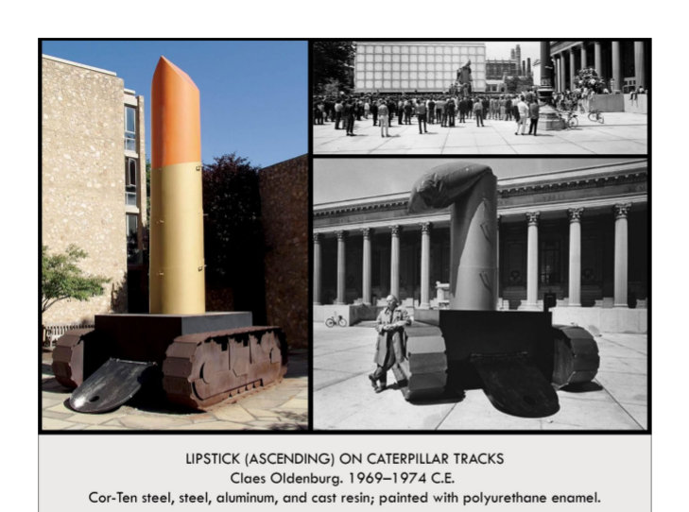

| **Form:**  a reaction of the original.  **Function:**  A pop art sculpture. Made for an anti war protest  **Content:**  bottom was intended as the platform where people would stand up and speak agents the vietnam war. There is a tank at the bottom to demonstrate war, the top is lipstick and inflates, is was suppose to be absurd, funny, insane, ironic and more.  **Context:** installed in newhaven in 1969 and is near the campus of yale. It was erected in secret and was a piece of gorilla street art. Ot s taking something masculin and putting something humorous and feminin under it. Created int he 20th century.  **Compare:**  like the dadaist they were reaction to the horror of there times with absertidy.  **150**  Late Europe & Americas |
| --- |

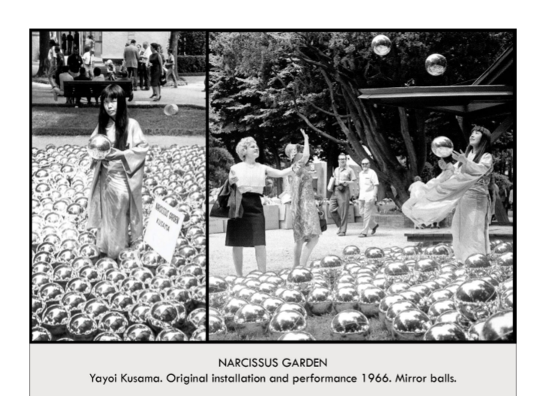

| **Form**: a happening- a performance are piece. 1500 large mirror balls.  **Function**: a piece of conceptual art to made a statement about hte people and about their narcissism  **Content**: the exhibit is made of milar globals and they can be blown up with air, and with these mirror balls she would hand them out to people. It was funny and made fun of the people and called them narcissists.  **Context**: conceptual. Young unknown japanese artist, when to the venus biennale- art show in venis and stages a happening, it was not sanctioned, she is doing her own thing. Today it is in a exhibbit but it was originally a performance piece. She sold them for 2 dollars each at the instillation.  **Compare:**  **148**  Late Europe & Americas |
| --- |

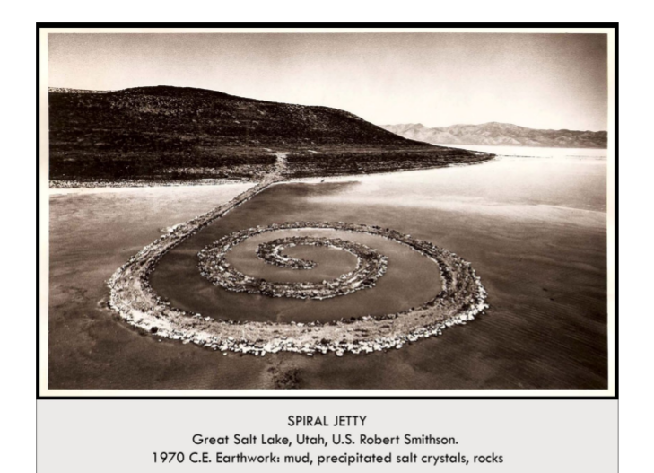

| **Form:** land art created by robert smithsom. Created from rocks. Mud, and salt crystals.  **Function:** an art made from its area, to mirror and express the surrounding area. Artistic intervention in the landscape.  **Content:** gutting out into the great salt lake in utah. When the waters rose the spiral jetty disappeared from sight. It changes with the water, it can be white, black, gray, or other colors. The art changes as the environment changes. Was not intended to be happy, ment to have a scene of decay and atrophy.  **Context:** A piece of Environmental and installation art.couldn't have made this anywhere else because land art is about fitting the art into the place( only art form that does that. Located in the utah desert. Greatest land art movement in the west. The most famous. It is no longer there. Made in 1970. He was a sci-fi fan and appreciated the. Artist wanted to make works that could not be bought or sold and wanted to separate from the gallery system.  **Compare:** Stonehenge ( artistic arrangement of rocks in a modern context) early primitive association with the landscape.  **151**  Late Europe & Americas |
| --- |

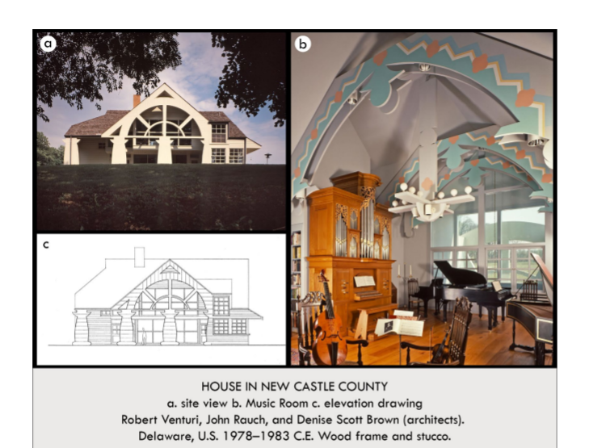

| **Form:** a quintessential example of a domestic example of postmodern  **Function**: for a family of 3, wife was musician, husband was a bird watcher.  **Content:** unbelievably eclectic, there is not symmetry, one side was all windows, one side was all music. There is a tympanum to romanesque cathedral, there are references to greek columns, there are repetitive windows= international. There is no balance at all. It is a mixture of a bunch of different types of architecture, it is mushing a bunch of thins together.  **Context:** Postmodern architecture ( make building unique and begin to deconstruct buildings and was the opposit of the international style)  **Compare:**  **152**  Late Europe & Americas |
| --- |